**Marathon Match - Solution Description**

**Overview**

Congrats on winning this marathon match. As part of your final submission and in order to receive payment for this marathon match, please complete the following document.

1. **Introduction**

Tell us a bit about yourself, and why you have decided to participate in the contest.

* Name: Zbigniew Wojna
* Handle: zbigniewwojna
* Placement you achieved in the MM:
* About you: Zbigniew Wojna is a deep learning researcher and founder of TensorFlight Inc. company providing instant remote property inspection based on satellite, aerial and street view imagery, primarily for the insurance industry. Zbigniew did his Ph.D. (with more than 9000 citations) at the University College London under the supervision of Professor Iasonas Kokkinos and professor John Shawe-Taylor. His primary interest lies in merging research opportunities and business needs for 2D vision applications, usually in the large scale settings. Zbigniew in his Ph.D. career spent most of the time working across different groups in DeepMind, Google Research, and Facebook Research. It includes the DeepMind Health Team, Deep Learning Team for Google Maps in collaboration with Google Brain, Machine Perception with Kevin Murphy, Weak Localization Team with Vittorio Ferrari, and Facebook AI Research Lab in Paris. His company TensorFlight Inc. was featured as the top 2 AI startups among a few hundred by InnovatorsRace50, top 30 out of 2048 teams by IPIEC Global, and closed ~$5M funding from the most prestigious investors in the insurance industry.
* Why you participated in the MM: Due to lockdown I had an opportunity to spend much more time on research, I wanted to compare different algorithms for building detection on satellite and study the previous solutions of SpaceNet and xView competitions.

1. **Solution Development**

How did you solve the problem? What approaches did you try and what choices did you make, and why? Also, what alternative approaches did you consider?

* I started by merging the baseline model and solution ideas from previous competitions. Followed the general semantic segmentation setup with unet architecture and postprocessing to extract building mask instances. Typically for MSCOCO and Cityscapes the best models use directly instance segmentation approaches like Mask-RCNN, but for buildings that are quite regular in shapes and do not suffer from occlusions, sem segmentation is potentially a better-suited approach.
* Things I have tried that did not help:
  + **Bigger efficientnet i.e. B6 B7 B8 L2**
  + ASPP Atrous Spatial Pyramid Pooling / Spatial OCR
  + 1x1 conv bottleneck
  + Smaller stride (higher resolution of features)
  + Global context pooling
  + **RGBI / Height prediction as auxiliary task**
  + **Deep watershed and distance transform as auxiliary task**
  + Auxiliary loss
  + Scaling focal loss pixel weight wrt building size
  + Fixing batch norm params in training
  + Warm up training
  + Augmentations: gauss noise, gamma scale, elastic transforms, flipping upside down, rotations 90 degrees, channel swapping

1. **Final Approach**

Please provide a bulleted description of your final approach. What ideas/decisions/features have been found to be the most important for your solution performance:

* The most important was the correct train/val split. Our estimates of the tile positions for train and public test dataset is below.

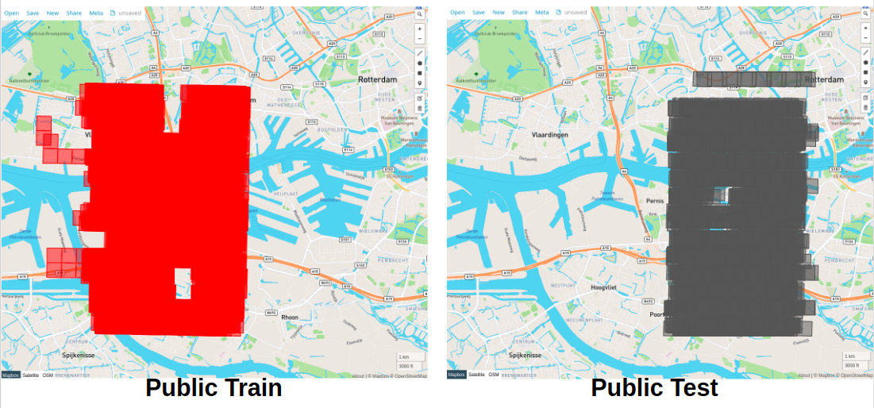

* You can see the overlap between them, which could cause the potential overfitting to the right part of the red area if you optimize public test scores. But the more crucial issue was that that images are difficult to interpret by the human eye and one may miss the fact that on average there are about 20 of them covering the same location. Therefore it was important to split the dataset by the location, and remove the neighboring overlapping tiles from both train and val dataset like on the image below. We estimated that there are ~200 unique tiles.

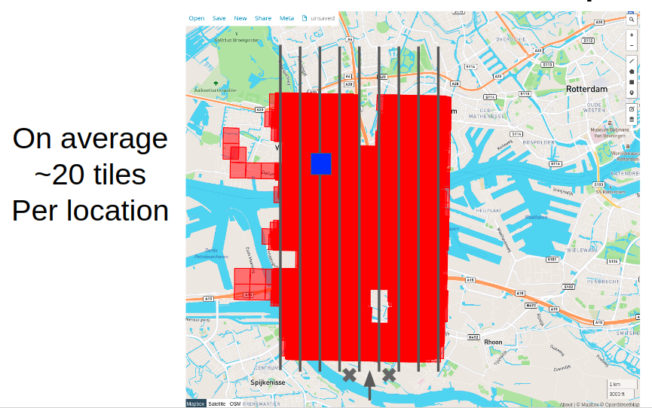

* I get used to training large datasets taking advantage of 4 cards or more in a single training. This dataset is much smaller than it may seem initially in terms of covered area, therefore it was more than enough to use 1 GPU for training and take advantage of trying more ideas and hyperparameters.
* Deterministic training was crucial to be able to compare results and develop ideas that help. As the dataset is relatively small, the val estimates were quite noisy and seed could impact a lot the metric. Functional.interpolate in pytorch is not deterministic.
* 3 segmentation tasks as binary masks with weighted loss: 1 x footprints, 0.25 x edges, 0.1 x contacts, edge width 1, contact width 4. Example target mask presented below:

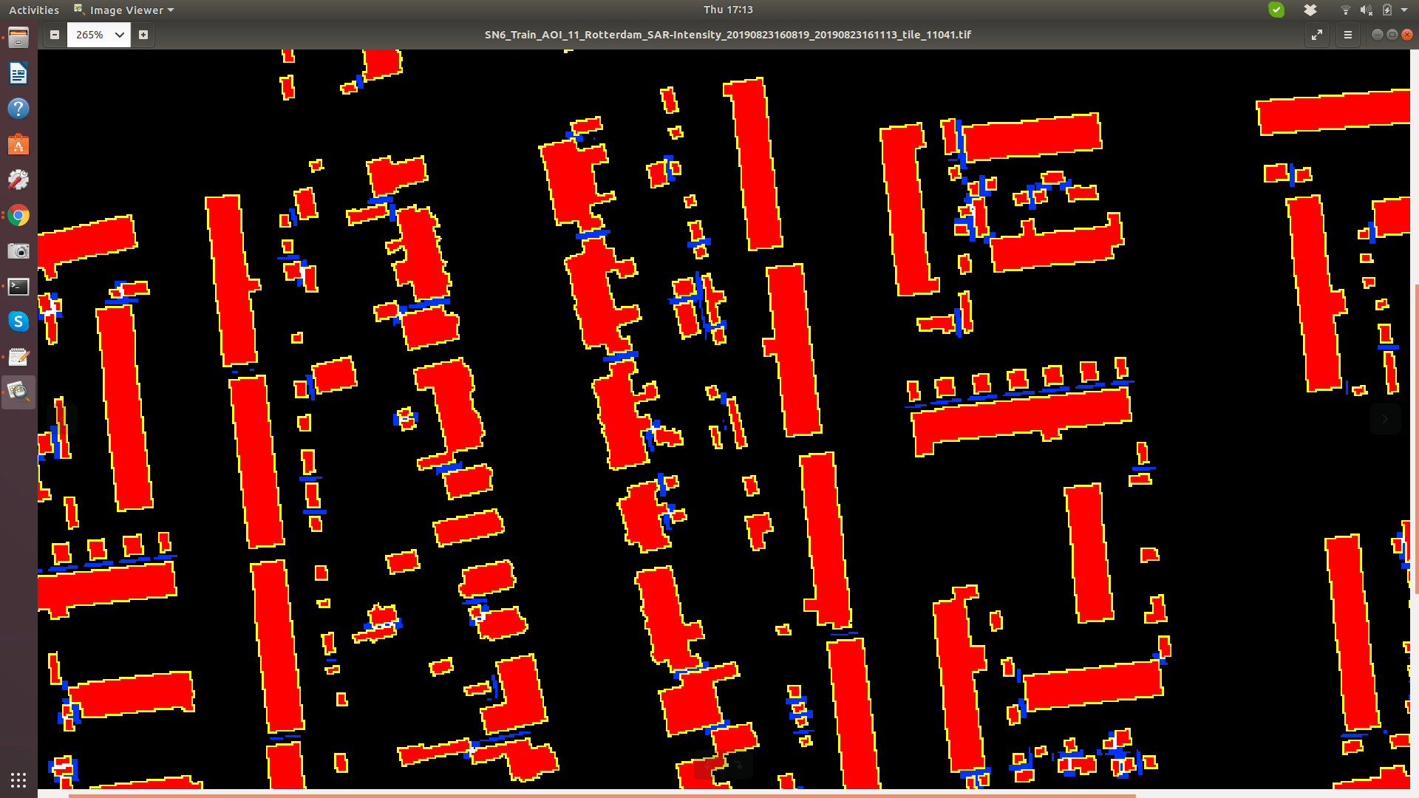

* Loss function: 1x weighted focal loss + 1x dice loss
* Weight for positive pixels: 0.5
* Weight per image: 0.5 + 0.5 * #Buildings
* Finetune EfficientNet B5
* 3 additional signals as extra channels in the middle of the network:
  + strip one-hot encoding - 204 channels
  + flight direction - single-channel 0/1
  + y tile coordinate - single-channel float in the range [-1, 1]

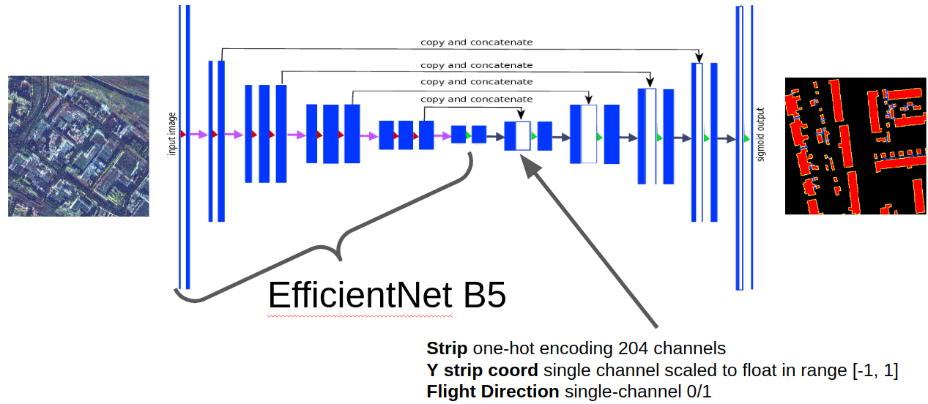

* Copy weight for 4th input channel and tried different channel ordering
* Remove the black part of the input image for training, it potentially helps with more accurate batch statistics when finetuning a pretrained network.

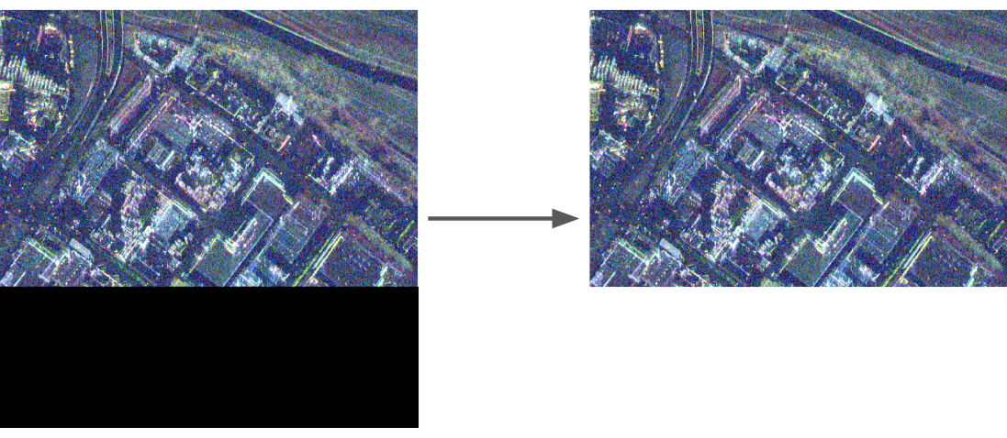

* Left-right flip helps, rotation and upside-down not, due to SAR artifacts from the reflection around water

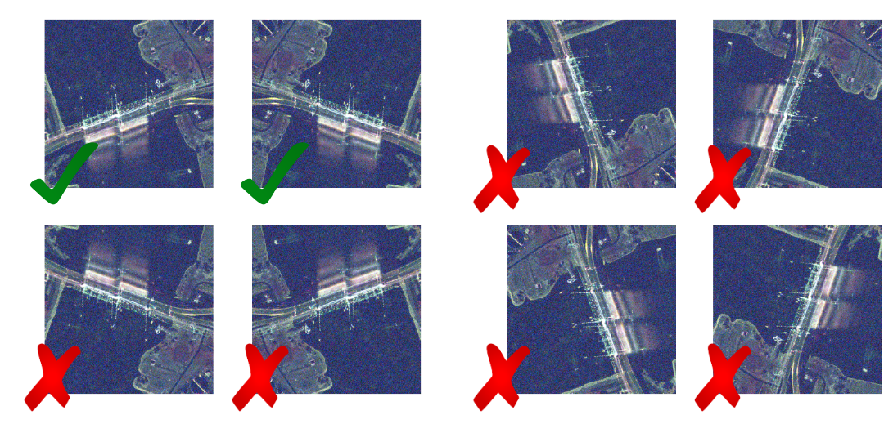

* Inference: 8 models in the ensemble
* Inference: test time augmentation: left-right flip, 3 scales

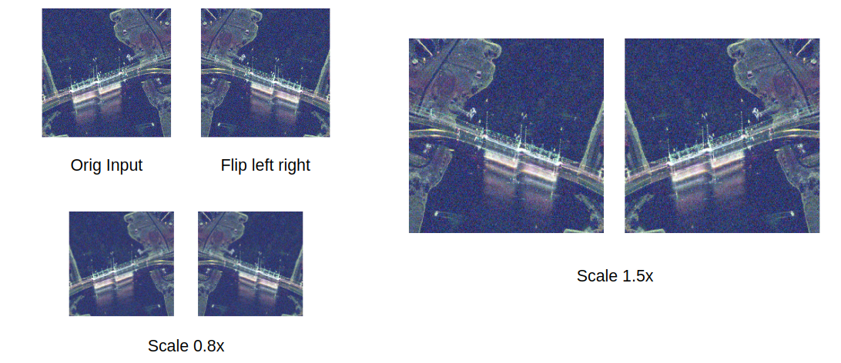

* Mask -> Polygons: I extended the watershed algorithm that I found to be very helpful. It was crucial to correctly parametrize the postprocessing, for example I removed every prediction below 120 pixels as they were very noisy, even though the metric required each building > 80 pixels.
  + footprint, edge, contact in range [0,1] after sigmoid transformation
  + mask = footprint * (1 - contact)
  + seed_msk = footprint * (1 - contact) * (1 - edge)
  + seed_msk = remove_small_connected_regions(seed_msk>0.75)
  + **mask = watershed(-mask, seed_msk, mask=(mask > 0.5))**

1. **Open Source Resources, Frameworks and Libraries**

Please specify the name of the open source resource along with a URL to where it’s housed and it’s license type:

* II used pretrained models from <https://github.com/rwightman/gen-efficientnet-pytorch>, which was approved by organizers

1. **Potential Algorithm Improvements**

Please specify any potential improvements that can be made to the algorithm:

* I still feel like we should be able to leverage somehow RGBI, height, and PAN imagery.
* Compare apples to apples with Mask-RCNN type of architecture
* Post-processing of polygons to catch false negatives.

1. **Algorithm Limitations**

Please specify any potential limitations with the algorithm:

* Currently it does not predict anything below 120 pixels.
* The model was trained for a specific direction of the radar.

1. **Deployment Guide**

Please provide the exact steps required to build and deploy the code:

1. Step 1 -
2. Step 2 -
3. Step 3 -
4. **Final Verification**

Please provide instructions that explain how to train the algorithm and have it execute against sample data:

1. Step 1 -
2. Step 2 -
3. Step 3 -
4. **Feedback**

Please provide feedback on the following - what worked, and what could have been done better or differently?

* Problem Statement: providing more insight into the location of tiles for training and public test datasets could help save time and frustration for some contestants, including me. It took me several days before I realized the problems with the train/val split.
* Data: Data collection process could be done much more efficient, against flying 20 times over the same area, SAR should be collected from 20x larger area, we could train much better models with it.
* Contest: all perfect, I would suggest limit more the inference time in the next competition and provide exact number of images for that. At the end of the day you do not want to use the ensemble in the production but probably 1 highly optimized model.
* Scoring: the confidence score in this competition is kind of useless, as objects do not overlap as it is common for MSCOCO and because in the spacenet metric we assigned maximally one prediction to a ground truth instance.

**NOTE**: Please save a copy of this template in word format. Please do not submit a .pdf